Pakistan Health systems Overview
Student's Name
Institution Affiliation
Course
Date

Abstract
Health is one of the most crucial aspect of any country. Pakistan spends nearly 1% of its GDP on the health sector, which is less than 6% recommended. This percentage is too low as many people chooses to go for private health services due to unavailability of adequate services in the public sector. In the region, the countries include Singapore, Pakistan, India, Nepal, Indonesia, Thailand, and Myanmar. As of 25th July 2020, Pakistan has recorded 271,880 cases, with 236,596 patient’s recoveries. Different programs in the nation fail due to the religious beliefs people have, and they fail to follow set guidelines.
Pakistan Health systems Overview
Introduction
The health sector is the most critical aspect of any country, as it directly affects other sectors. The current Coronavirus pandemic is an ideal example of how significant and sensitive the health sector is for developed and developing countries. Pakistan spends nearly 2% (as shown in figure 2) of its GDP on the health sector, which is less than 6% recommended by the WHO (worldbank, 2020). Consequently, the nation faces a considerable number of preventable diseases as the Government doesn't put enough resources into the healthcare system. This assessment will give a detailed overview of the Pakistan health care system based on the recent statistics and reports. The Government's failure to invest heavily in health care focuses on citizens seeking medication from unqualified medical practitioners, which has deadly consequences.
South-East Asia region
The region has a rich ethnic diversity, linguistic and geopolitical diversity, and diverse religious and social practices. In the region, the countries include Singapore, Pakistan, India, Nepal, Indonesia, Thailand, and Myanmar. It has a population of about 1.8 people, with India the most populated (Illinois, 2020). On average, the life expectancy stands at 70 years, with the majority of the population being the youth. One of the most interesting facts about South Asia is that India had the greatest GDP of us $ 1939, while Afghanistan stands at the only US $ 580. The Maldives is the smallest nation in the region, by population and size, although it is known to be a honeymoon destination (Bager, 2020).
Pakistan's state of health
According to the WHO report, Pakistan is rated to have unsatisfactory coverage and
Unsatisfactory public healthcare services which focus people on turning to the private sector. The reports suggest that the level of depression has risen. There is no evidence that the Government has a coordinated national system to attain a comprehensive mental health resolution plan. HIV infection is on the rise, with 82% of the recent cases of young adults, because of high sexual abuse in the nation (avert.org/, 2020). A recent study by Mundi Index suggests the mortality rate stands at 180 lives per 1000000 livers birth.
COVID-19 in Pakistan
As of 25th July 2020, Pakistan has recorded 271,880 cases, with 236,596 patient’s recoveries. The nation has 5,787 deaths, although the Government plans to end the remaining 29,504 active cases (Worldometers, 2020). This record illustrates the commendable effort the Government has put to end the airborne virus. The figure below shows the general numbers of the coronavirus cases in the south Asia region.
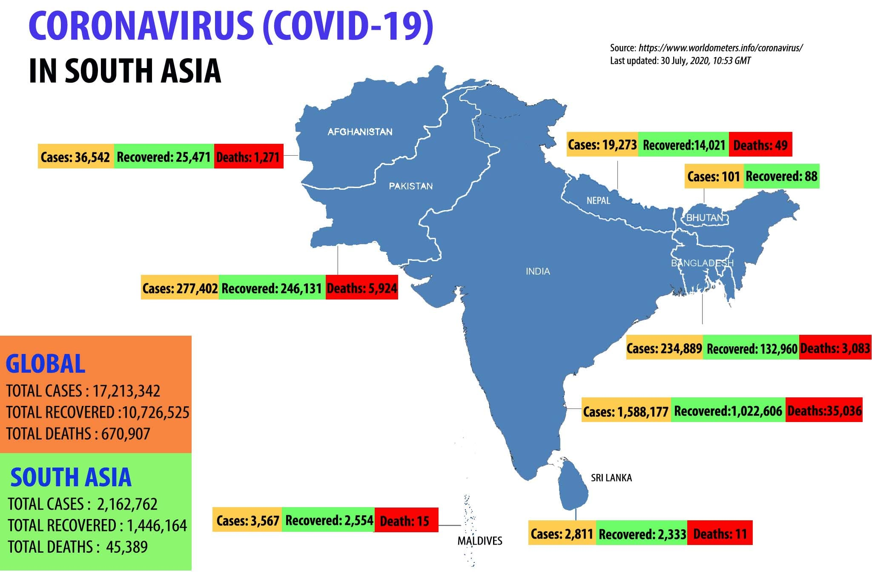
Figure 1 General numbers of COVID19 in the South Asia region. Source WHO website
Health programs and their failure
Pakistan has placed various health programs in the nation, which are driven by the Government and the nongovernmental organization. The Epidemics Prevention and Control Program is responsible for the fight against the coronavirus (Mushtaq et al., 2020). Other programs include; Punjab AIDS Control Program, Nutrition Program, National Maternal, and Child Health Program and the Extended Program on Immunization that are forefront in fighting against different diseases (WHO, 2020). The nation has religious diversity, which makes it hard to implement some of this program. Further, the road system is not good, making it hard for health workers to reach patients.
The national prevalence of HIV in Pakistan stands at nearly 20% among the IDUs. Graph 4 shows the general HIV/AIDS cases in Pakistan, with many people on the ARVs. The national Aids control program has failed to control diseases due to countries like Bangladesh, which has less than 0.1% of the population (Khan, 2019). Different programs in the nation fail due to the religious beliefs people have, and they fail to follow set guidelines. The Government must invest more in the health sector to make the system better.

References
Worldometers, W. (2020). Coronavirus Update (Live): 17,345,261 Cases and 673,169 Deaths from COVID-19 Virus Pandemic - Worldometer. Worldometers.info., from https://www.worldometers.info/coronavirus/?fbclid=IwAR2eH6CqZJ3NQKJYlFkGwOtUcqXwxqgVqixOXzSje8_Xun3OaDWPz2NgMZs.
WHO, w. (2020). WHO | Regional Office for South-East Asia Emergency Programmes. Who.int. Retrieved 30 July 2020, from https://www.who.int/hac/network/who/ro_searo/en/.
avert.org/, a. (2020). HIV and AIDS in Asia & the Pacific regional overview. Avert. Retrieved 30 July 2020, from https://www.avert.org/professionals/hiv-around-world/asia-pacific/overview.
worldbank, w. (2020). Current health expenditure (% of GDP) | Data. Data.worldbank.org. Retrieved 30 July 2020, from https://data.worldbank.org/indicator/SH.XPD.CHEX.GD.ZS.
Bager, S. (2020). Big facts: Focus on South Asia. Ccafs.cgiar.org. Retrieved 30 July 2020, from https://ccafs.cgiar.org/fr/blog/big-facts-focus-south-asia#.XyMeRSgzbIU.
Illinois, i. (2020). South Asian Countries – International and Area Studies Library – U of I Library. Library.illinois.edu. Retrieved 30 July 2020, from https://www.library.illinois.edu/ias/sacollection/sa_countries/.
Khan, S. (2019). Situation Analysis of Health Care System of Pakistan: Post 18 Amendments. Health Care : Current Reviews, 07(03). https://doi.org/10.35248/2375-4273.19.07.244
Mushtaq, K., Hussain, M., Afzal, M., & Gilani, S. (2020). Factors Affecting Health Seeking Behavior and Health Services in Pakistan. National Journal Of Health Sciences, 5(1), 30-34. https://doi.org/10.21089/njhs.51.0030

Appendix
Figure 1 General numbers of COVID19 in the South Asia region. Source WHO website 5

Appendices
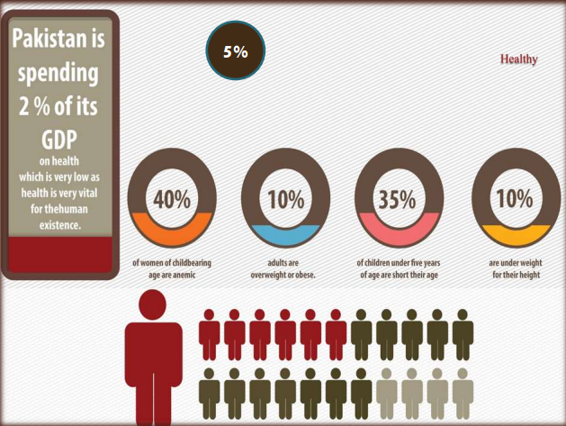
Figure 2. Health budget allocation in Pakistan. Source (Mushtaq et al., 2020)

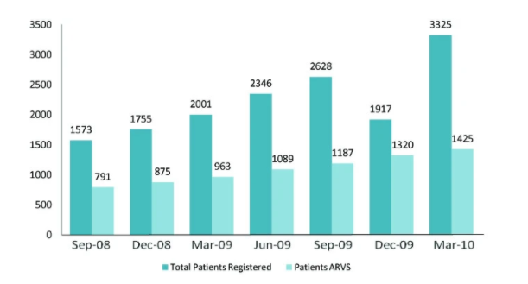
Figure 4. The number of infected and reported patients infected with HIV. Source WHO.

